**User Registration**

1. First Name should consider only characters.

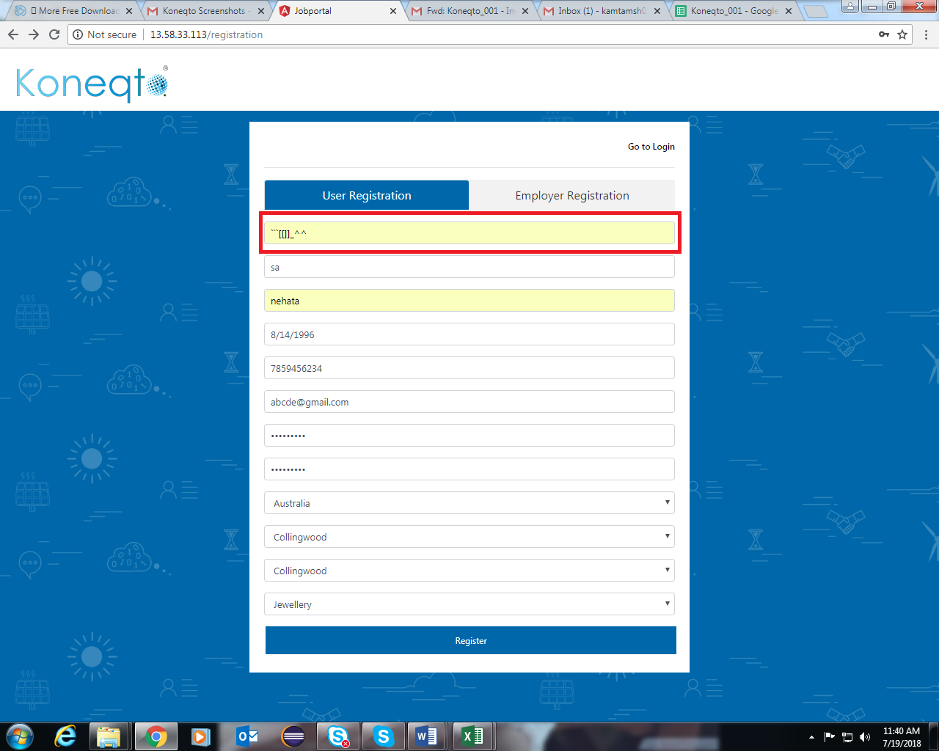

2. Last Name should contain only characters

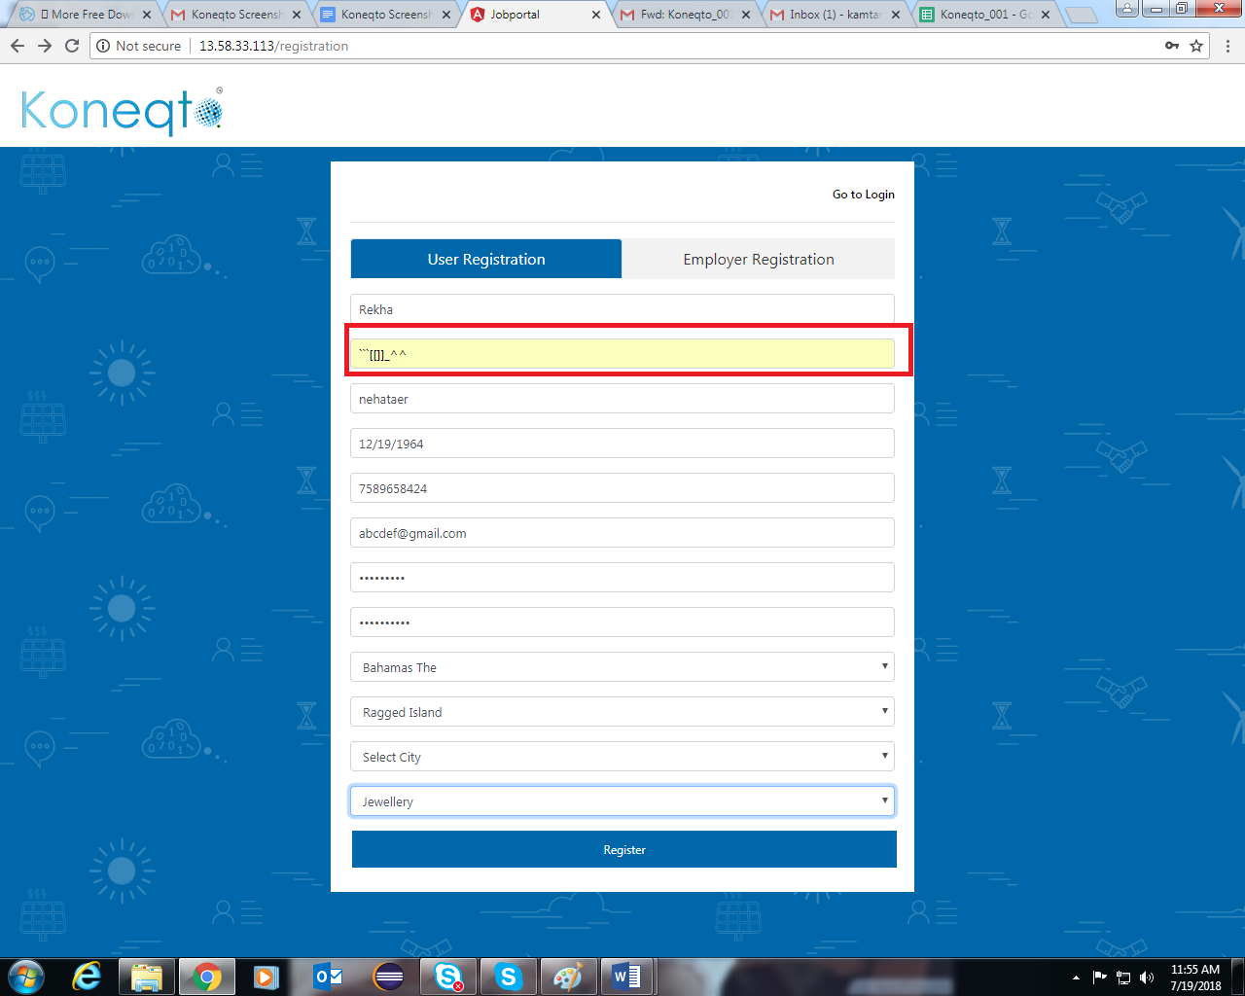

3. User Name should contain minimum 3 characters 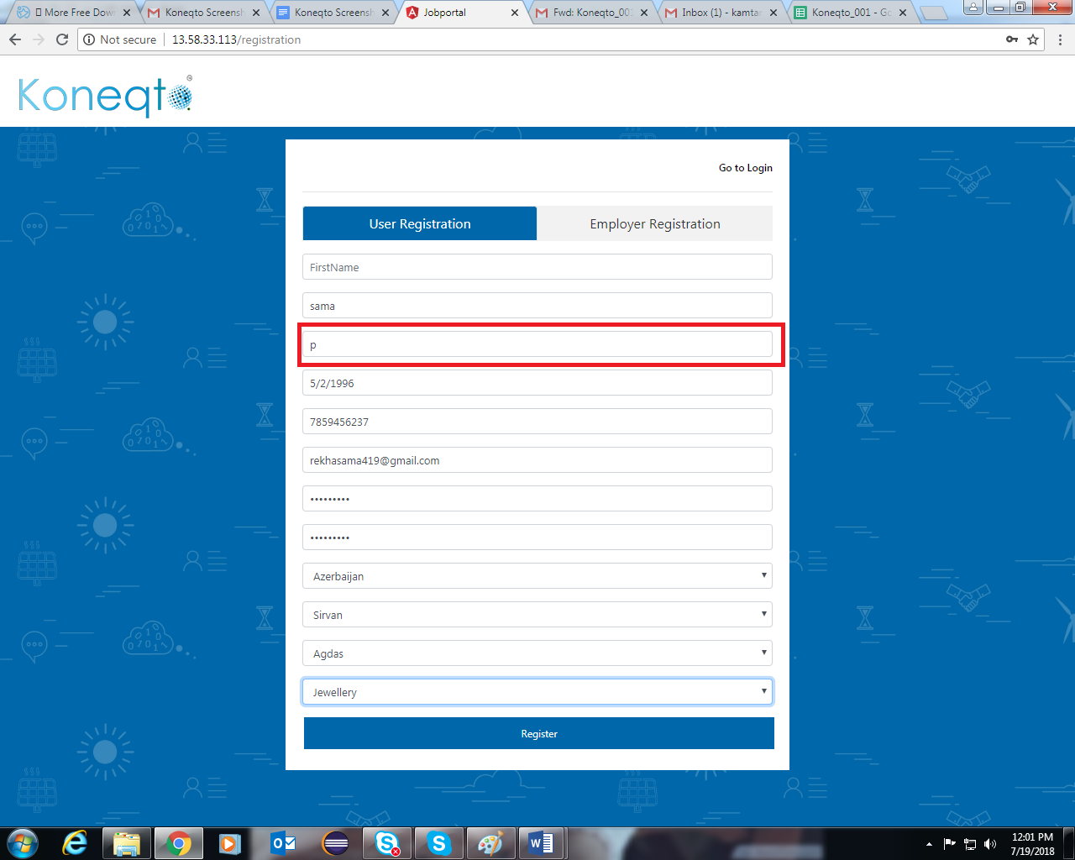

4. Date of Birth should start from 19th Century.

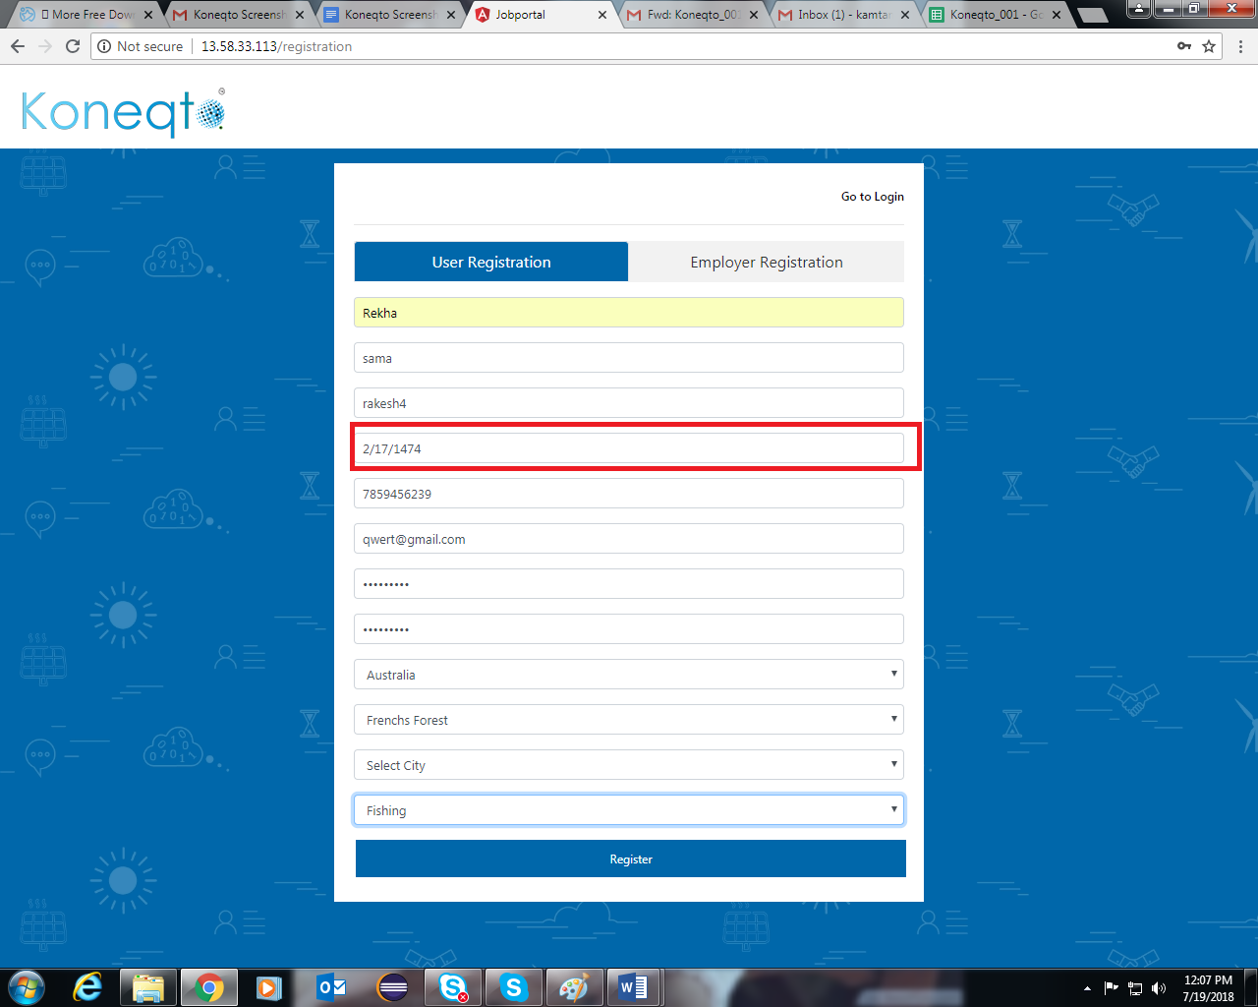

5. Mobile Number format should display according to Selected Country

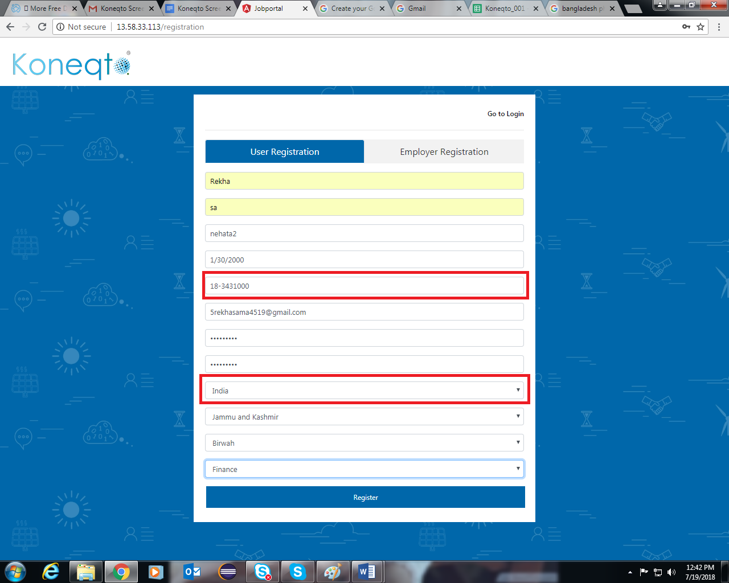

6. The domain of email id should be of .com

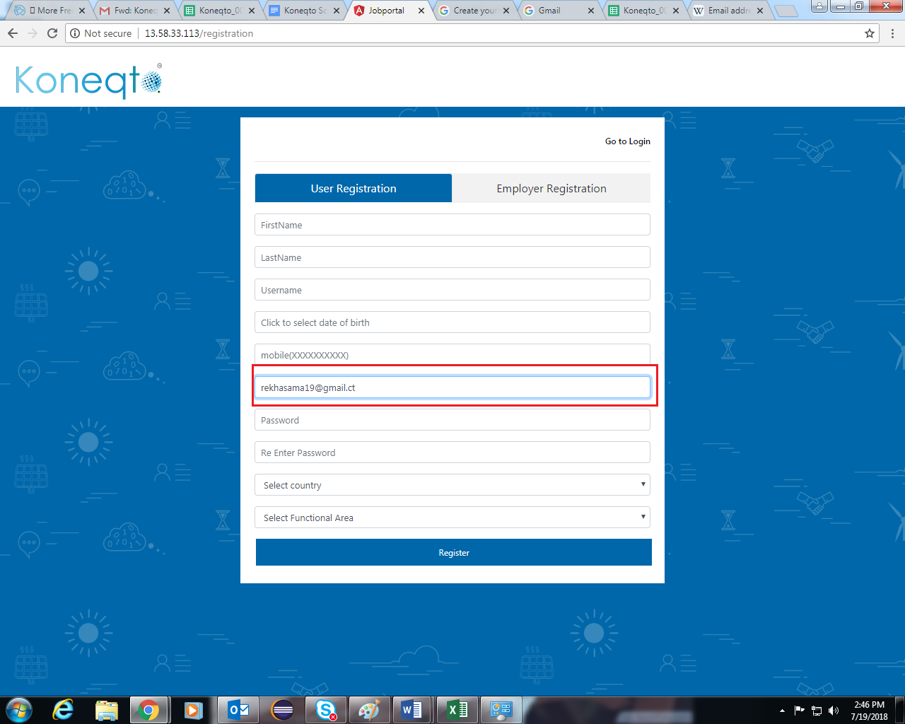

7. Password and Retype Password should have the option of show/Hide

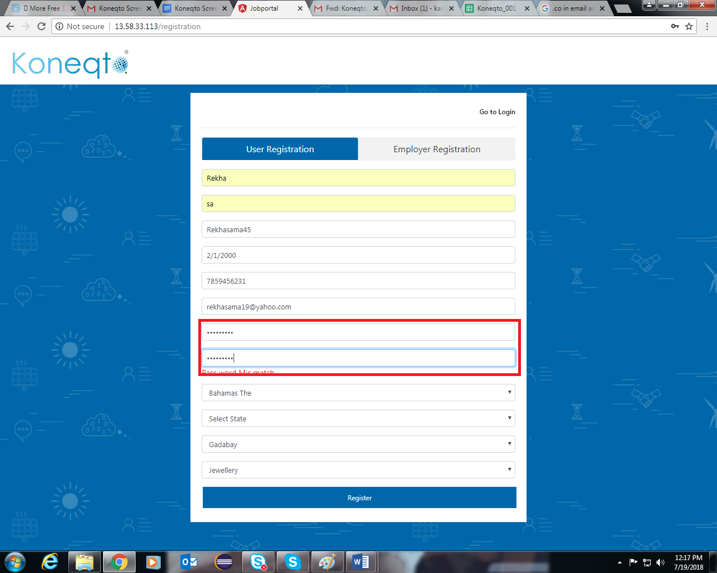

8. The drop down should contain only states but not villages and districts

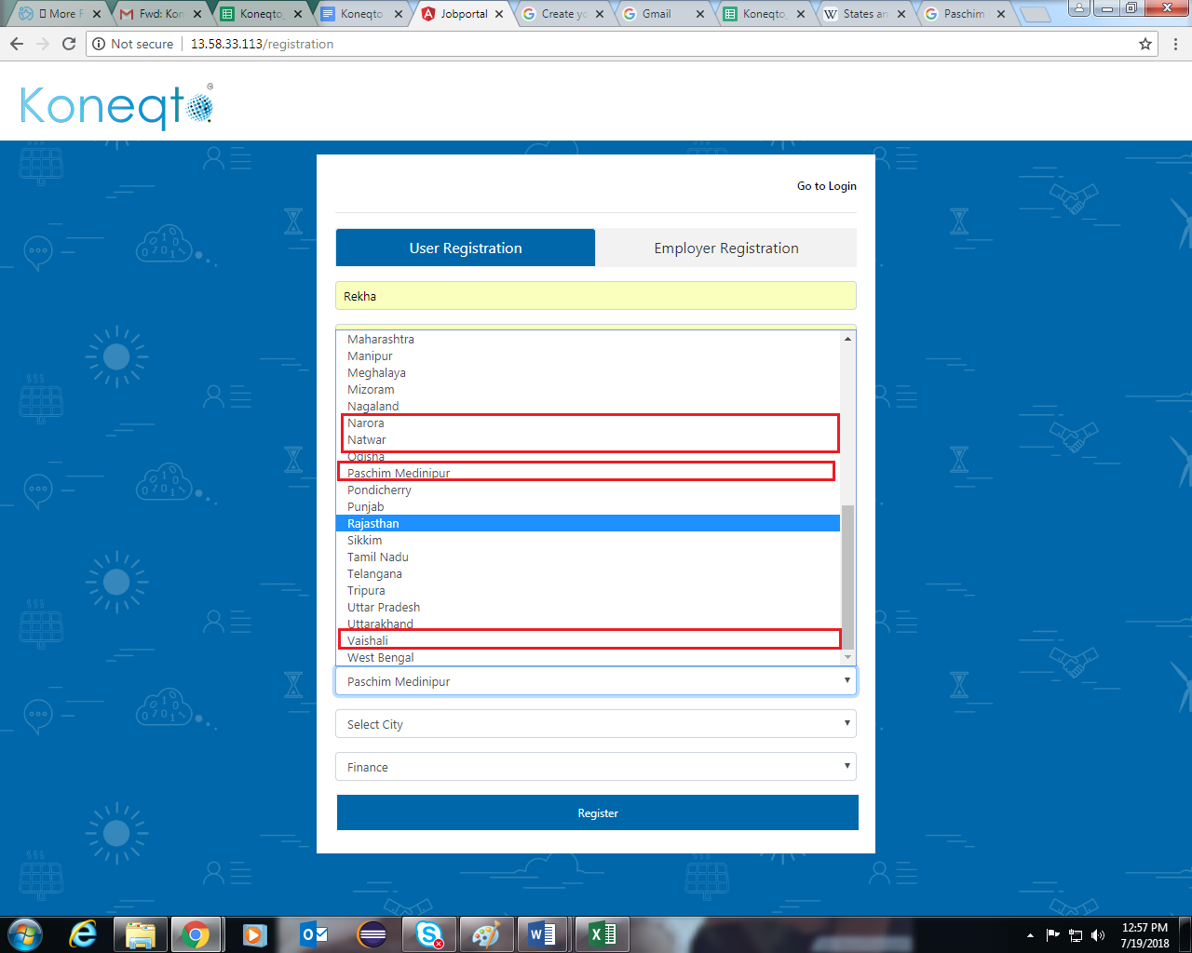

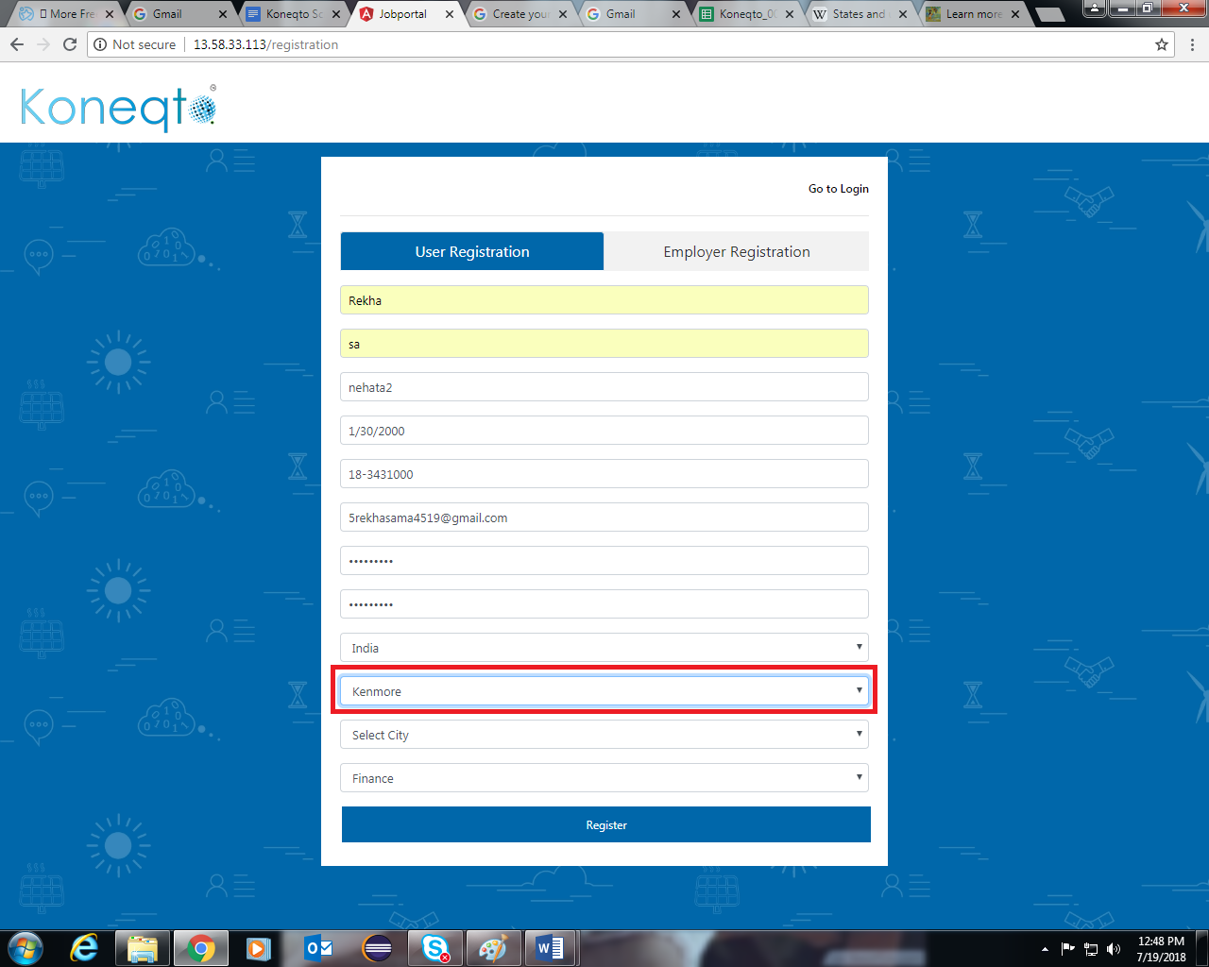

9. When user clicks on the other in functional area it should display the text box where the user can enter his/her respective Functional Area.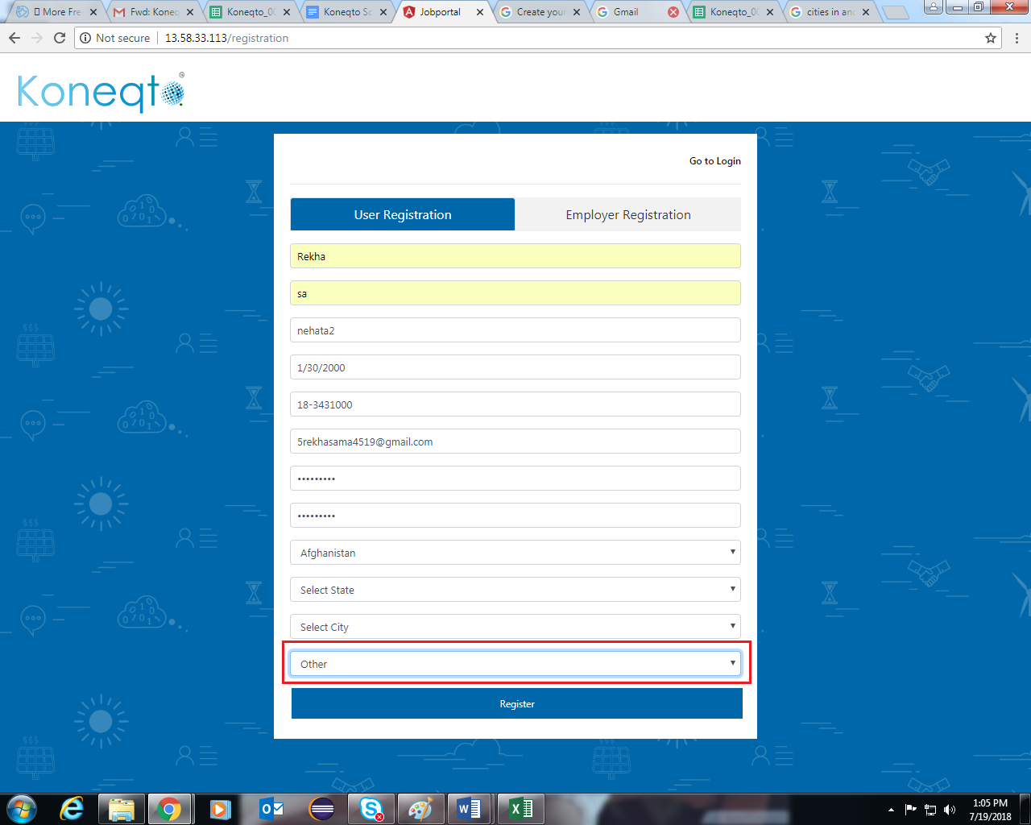

10. Go to Login should be highlighted.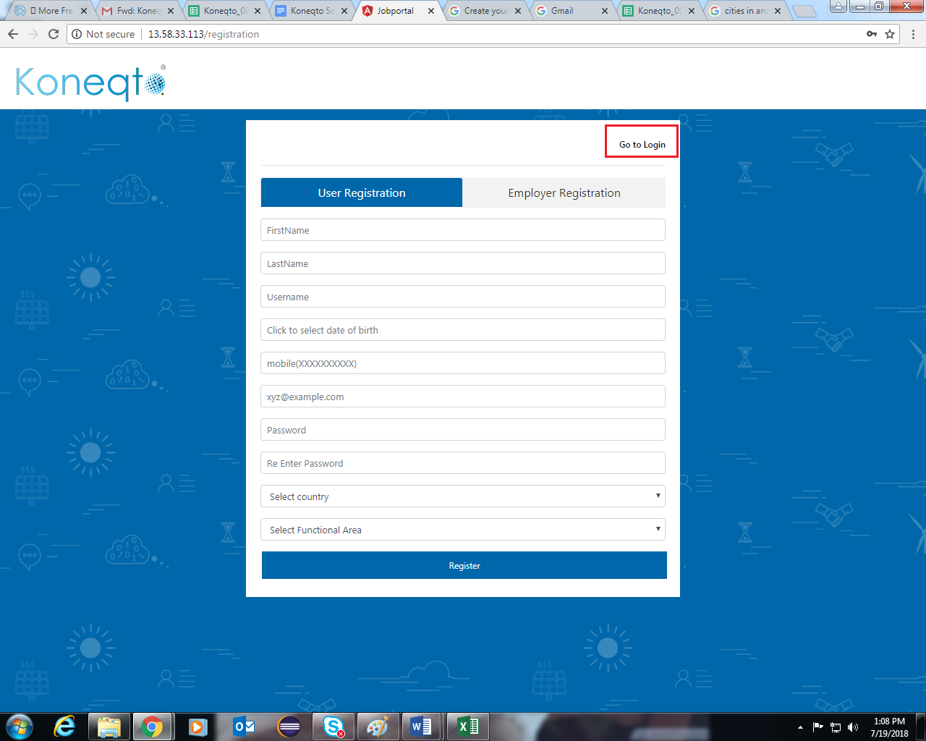

**LOGIN**

11. In Don’t have account text comma ( , ) should be replaced with apostrophe(‘)

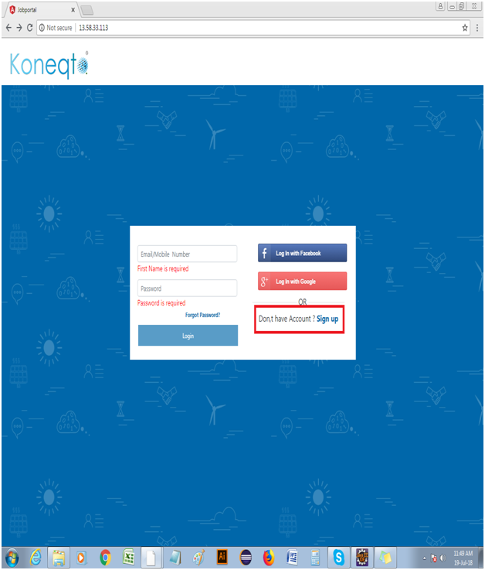

12. In login module, placeholder should be Email/Mobile number/User name

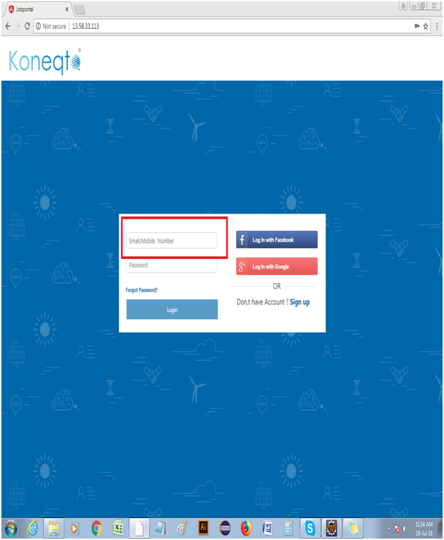

13. In login module, if enter Email id/mobile number field is empty. Error message should be ” Email id/mobile number is required”

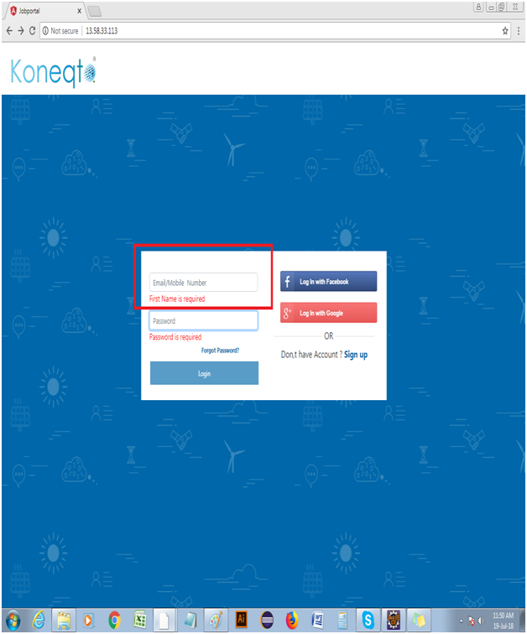

**Employee Registration**

14. Company name is accepting spaces

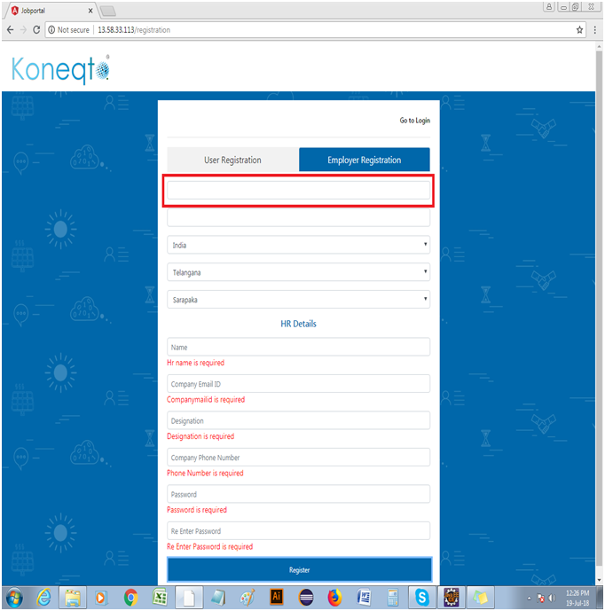

15. Company name is accepting special characters

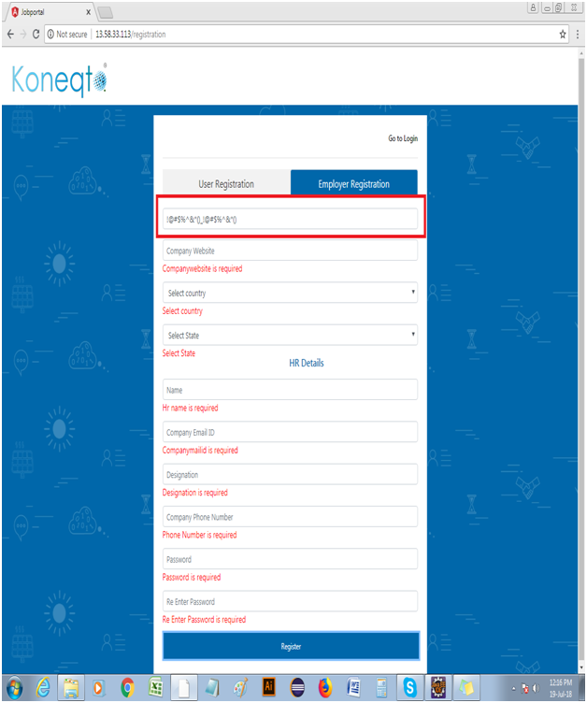

16. Company name is accepting numeric values

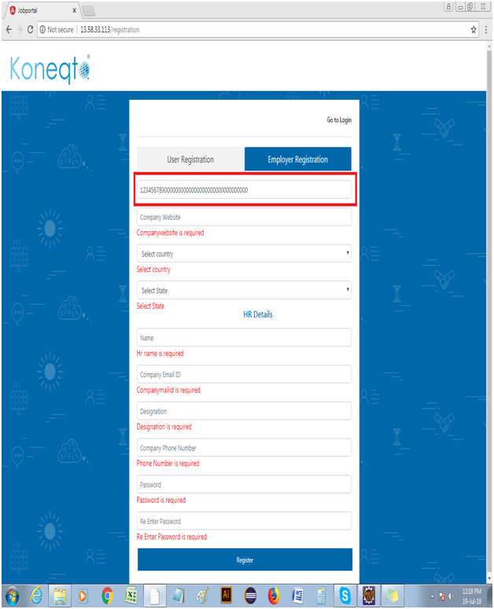

17. Company website is accepting unlimited characters

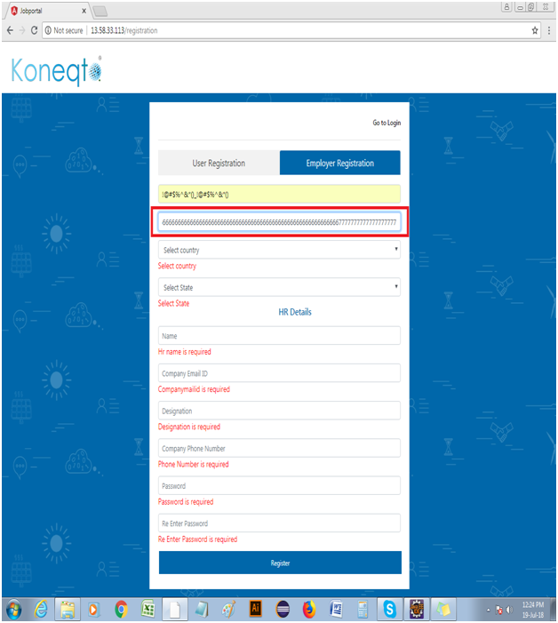

18. Company website field is accepting alphanumeric, special characters without any domain name (.com, .in, .org)

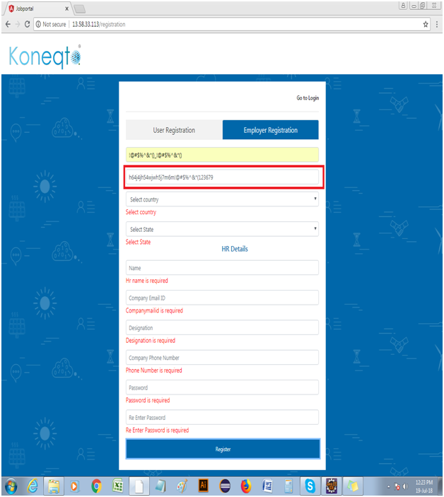

19. Company website is accepting spaces

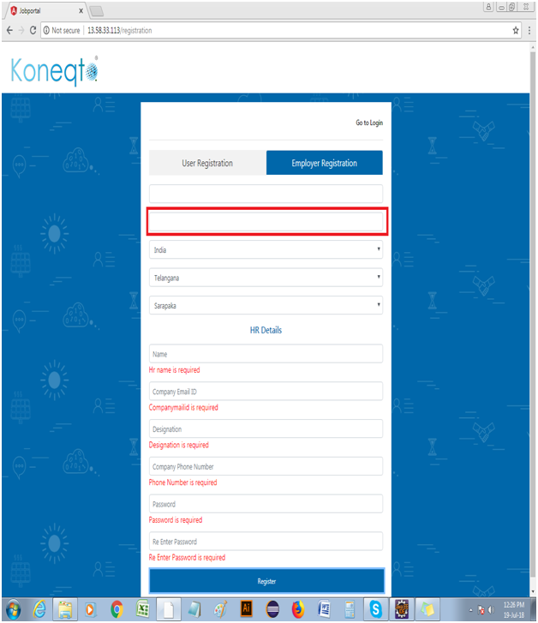

**HR DETAILS**

20. In Employer Registration module name field is not accepting spaces

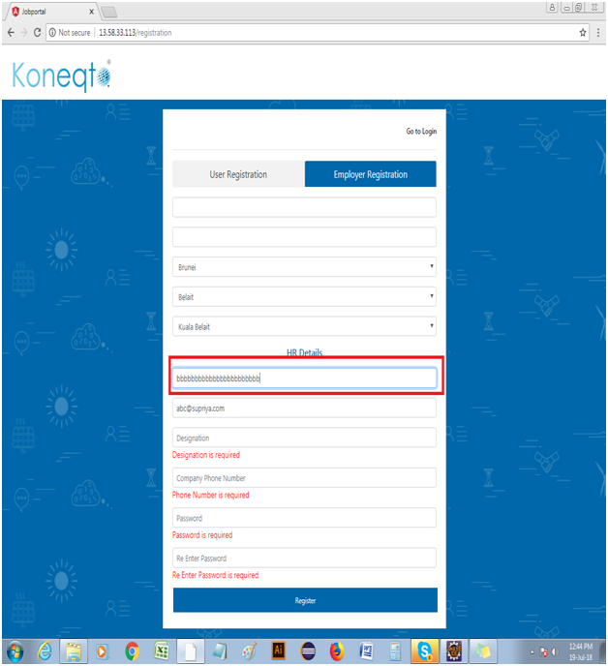

21. Company mail id field is accepting unlimited characters

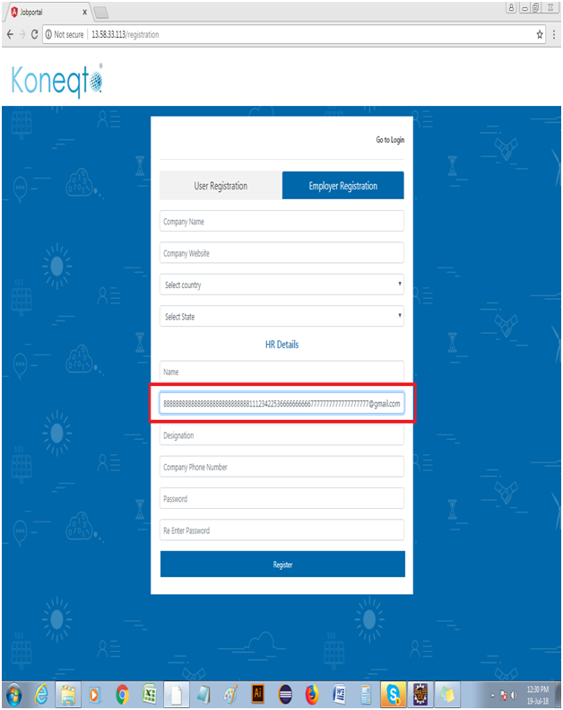

22. Designation is not accepting spaces

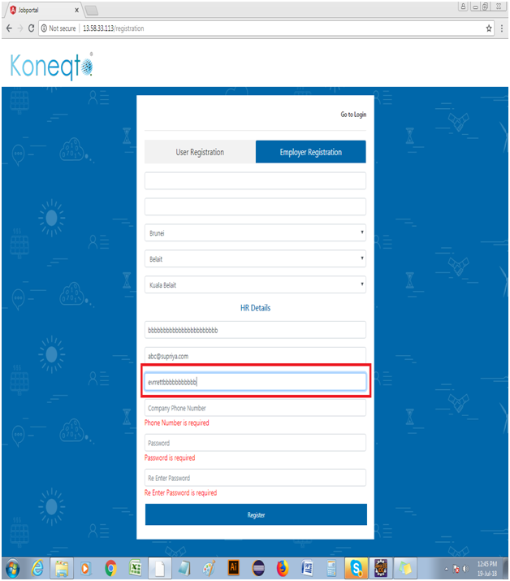

23.The drop down of states should contain only states but not villages and districts

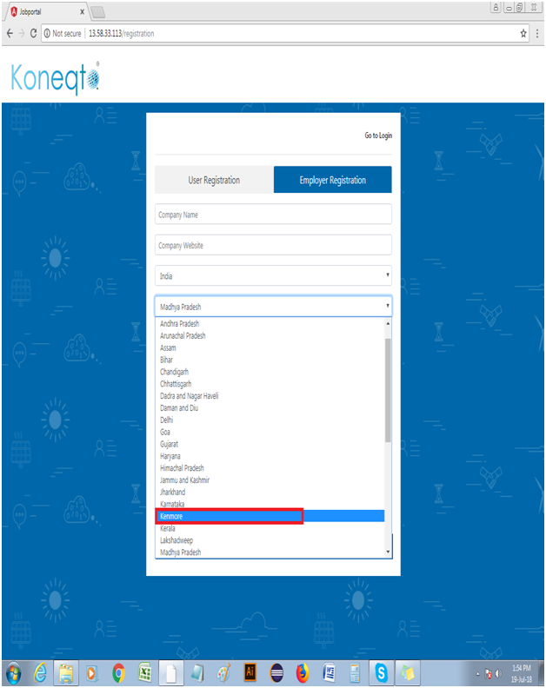



**POST A JOB**

24. Location should not accept numeric & special characters.

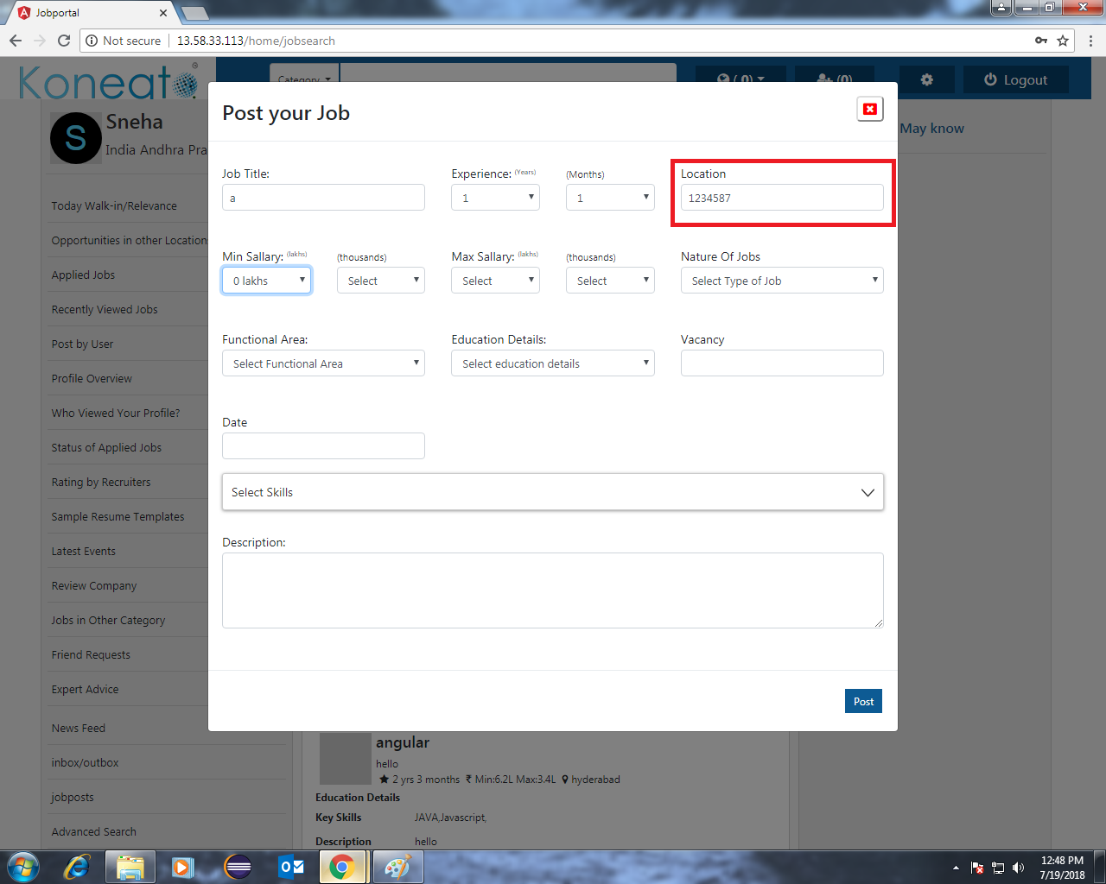

25

* Job title should not accept special characters and single letters
* Min salary & Max salary: Min salary should not be more than Max salary.
* Min Salary &Max Salary should not be zero.
* Salary spelling Mistake
* Vacancy: Vacancy should not be zero.
* Description: It should accept min 5 characters (Combinations of Alphanumeric and Numbers).

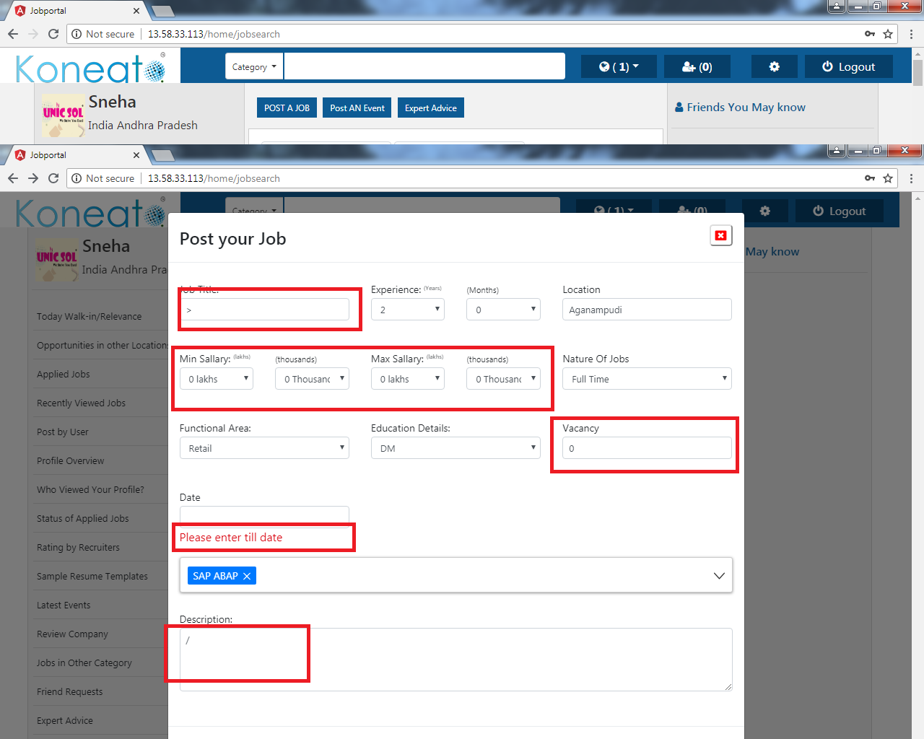

26. Skill/Company (mention slash here)

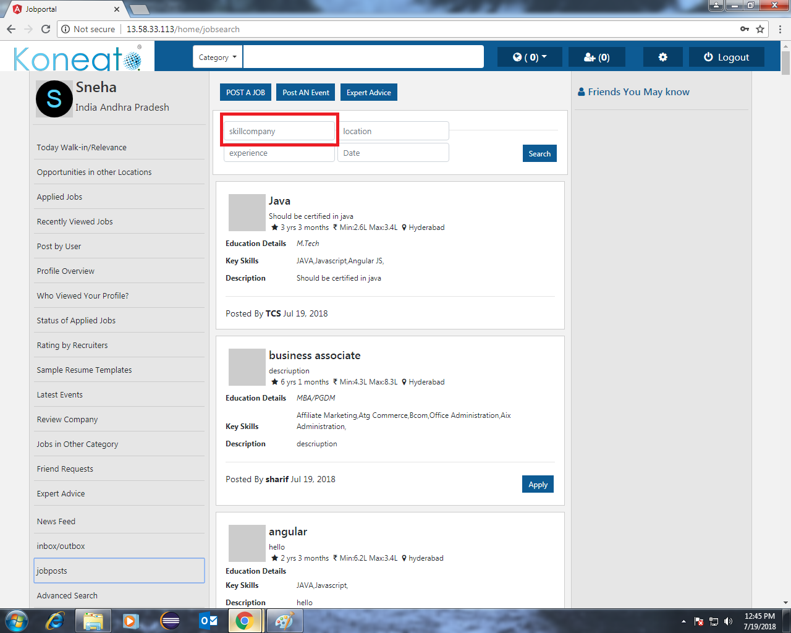

27. Educational Details: Insert all the education details. 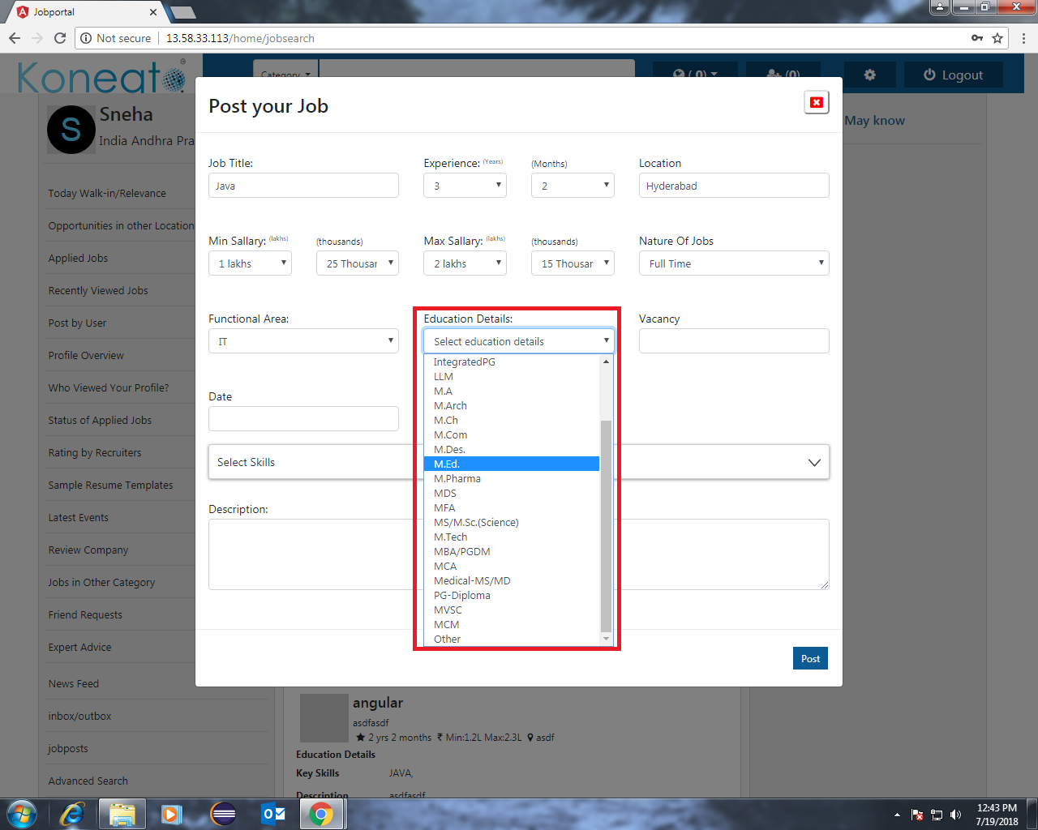

28. Skills: When skill is not selected then Error message is not displayed

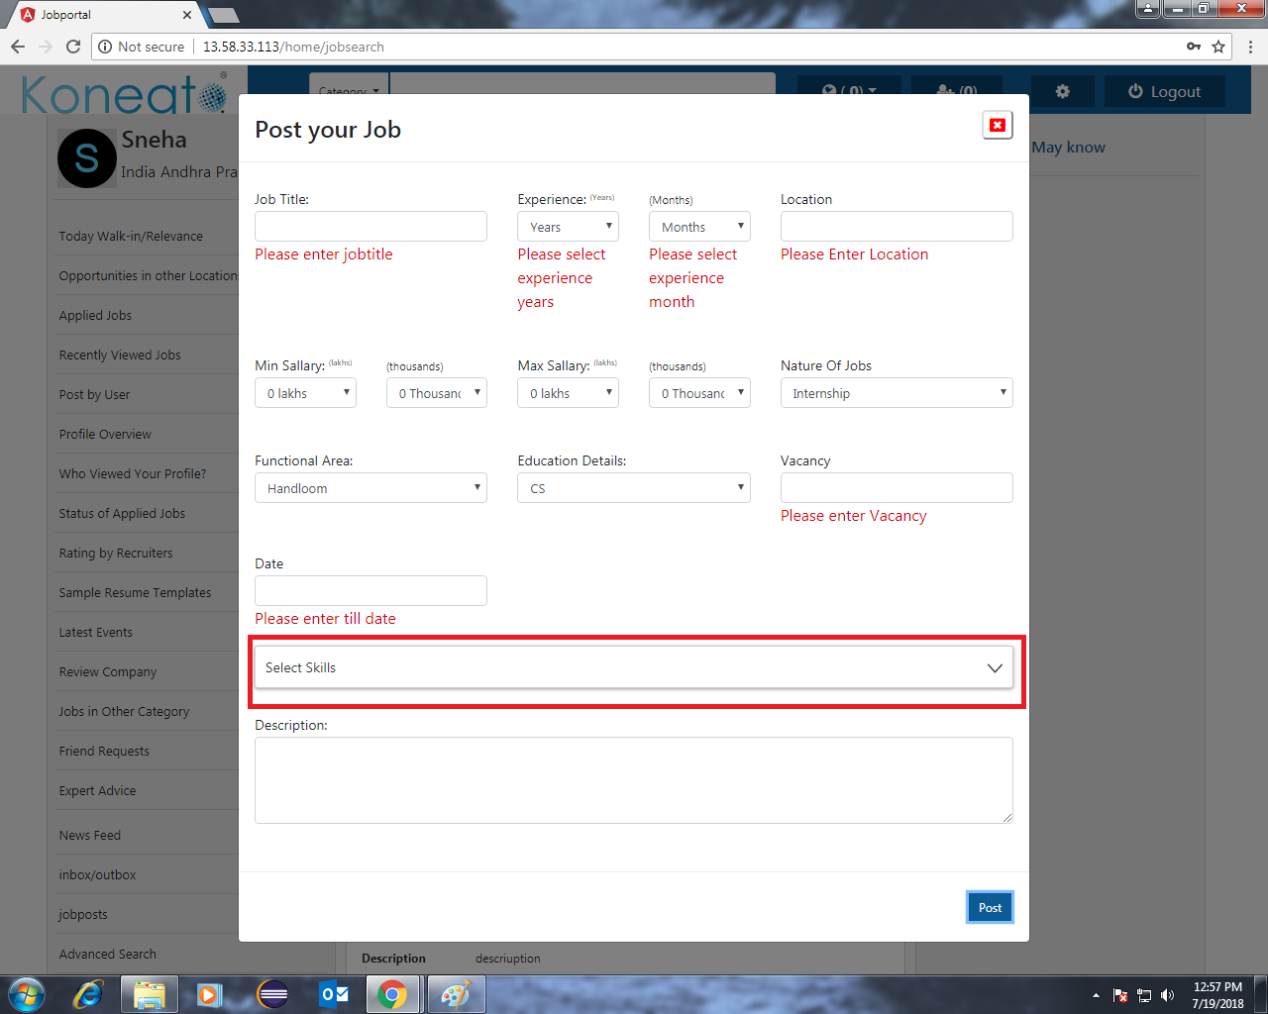

29. Min & Max Salary: When we select salary ‘0‘ it is automatically displaying ‘1.1lakhs’.

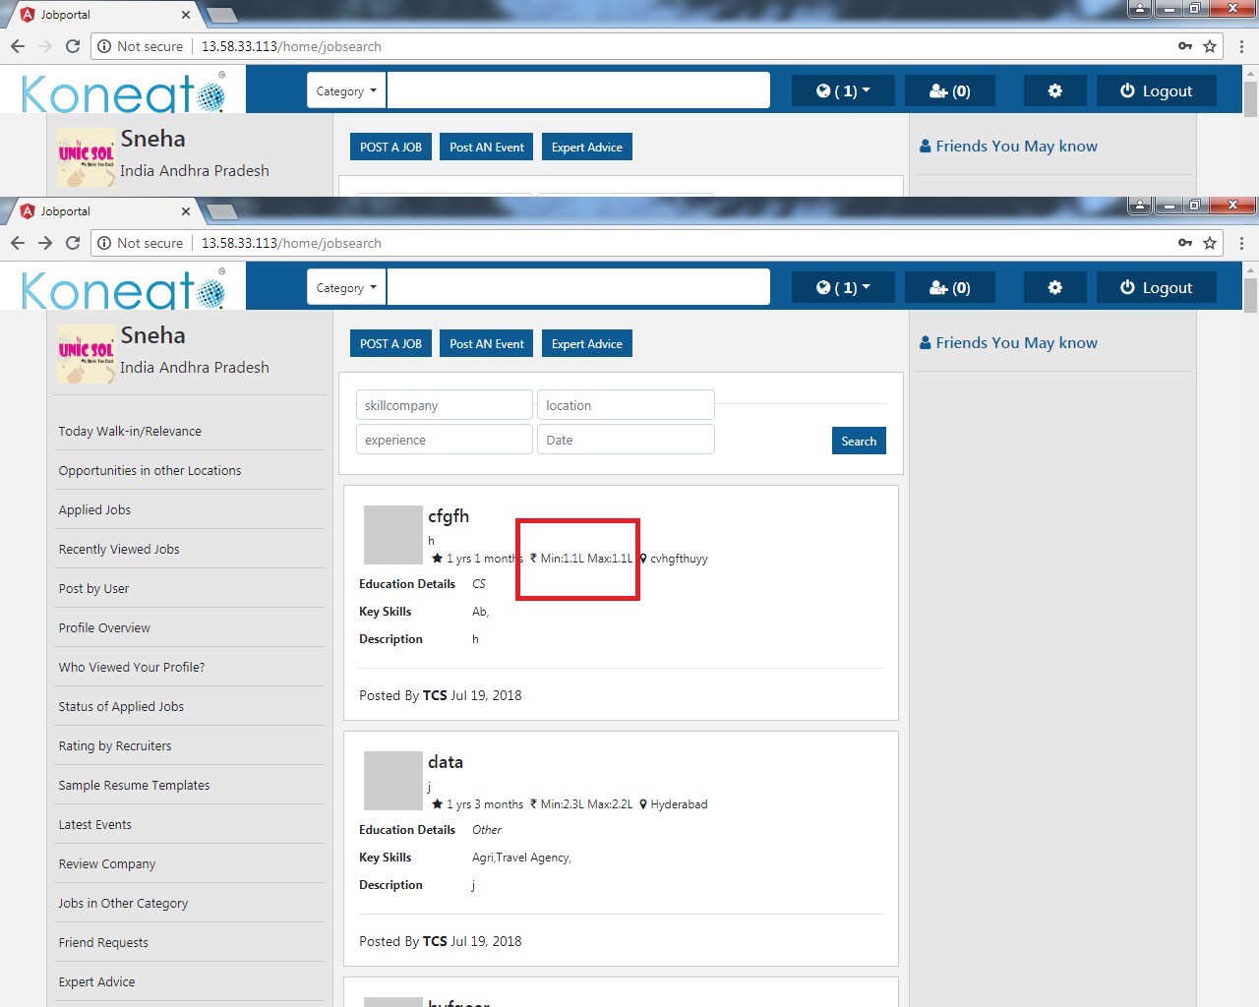

**Expert Advice**

30. Description should contain minimum 15 characters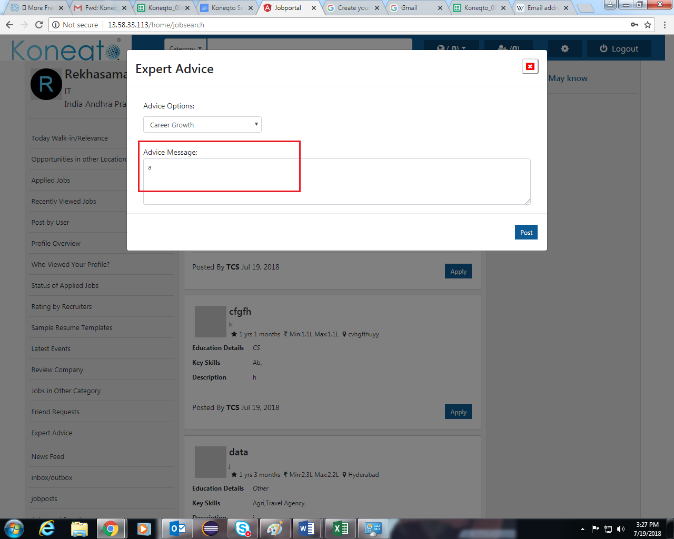

31. Advice message should contain the characters and Alphanumeric.

